* **Was the project a success? Why or why not? (Be honest!)**

Yes, because of the design choices and planning we did from the beginning, we all agree that we accomplished more than we expected to at the first call with our sponsors. Instead of a simple game that went through the very basics of orthopaedic surgery, we were able to create a game with an extensive anatomy review as well as multiple, in-depth trauma scenarios. In addition, we all believe that we effectively narrowed down our sponsors’ initial requests into one product that fulfilled them all. And instead of a game with purely information and transitions between screens, we implemented quality graphics that made the game more visually appealing and fun for high school students. Our sponsors gave us the technical information to lead us on the right path, and we were successful because we took this information and designed trauma scenarios that inexperienced students could comprehend

One possible negative was that there was not as much interaction with our sponsors as we expected. They were never able to meet us in person and our video calls were not as frequent as expected. However, the information they gave us was very useful each time we spoke with them. There were also a couple of add-ons that we would have liked to implement, but we did not have enough time. Giving players a score at the end of each scenario and having sounds play for certain actions would have been great, but we were focused on making sure our original product was as functional as possible. It also would have been more illuminating to have students try the game and give feedback that we could adapt from.

* **What went right with this project?**

Using Unity saved us a lot of time in developing and allowed for more innovation with our project. The cloud collaboration was seamless as well, and it made integrating our individual parts of the project much easier. Because of the way the program works, it also involved very little adapting between Apple and Android builds. We as a group were also able to portray information correctly despite not being medical students and not receiving many resources from our sponsor to use in the project. The graphics that we used in the project were also cartoonish and informative as was requested by our sponsors.

* **What went wrong with this project?**

Our biggest mishap of the project involved attempting to employ a graphic designer to create the artwork for our app in order to use more of our allotted budget. We agreed on a deadline and price, but the designer was unable to deliver what we needed in time. We lost some time, but luckily, we created very professional graphics ourselves that still had the cartoonish appearance we were looking for. After integrating the different parts of the project, we also had an issue with maintaining the same scale between different screens when building the project as a whole into an app. Lastly, there were a few times when we ran behind schedule, but once we found the time to sit down and knock out a few things at once, we were always able to make up that time.

* **What did we learn as a group from this project?**

We learned that setting hard deadlines for concrete progress is vital to a project’s success. It is also very important to plan out your interface so that it is adaptable for future development such as adding graphics. And we learned that being under budget is fine, and it is not worth wasting time on unnecessary aspects of the project to fully utilize it.

Nicholas Duffner

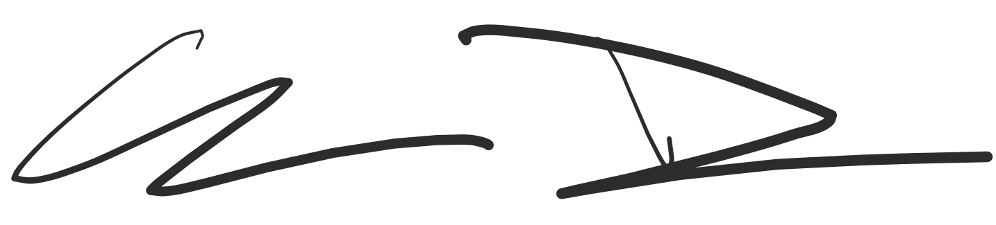

Chenning Zhang

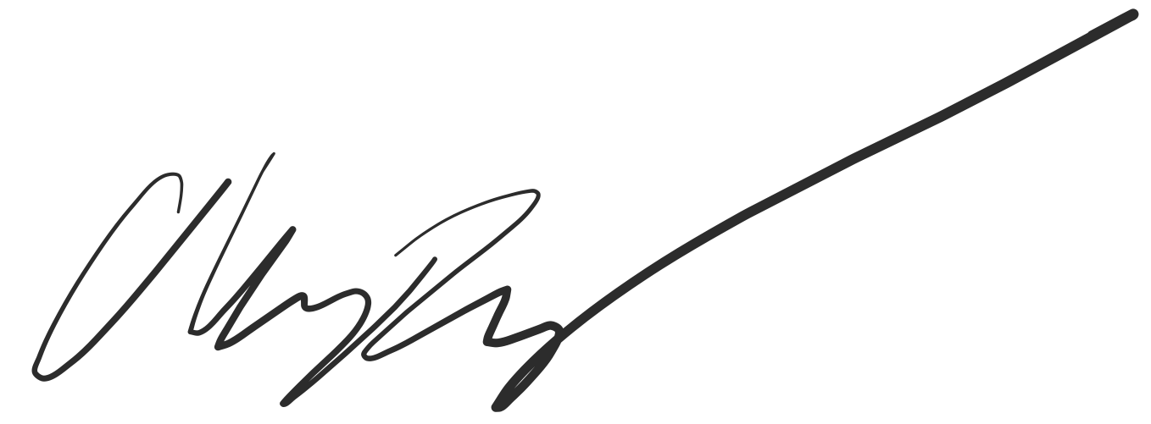

Amber Graham

